**Salesforce Org Expiration – Rootstock Procedure**

1. Login to LMA org with your user details and navigate to ‘Rootstock Orgs’ tab.

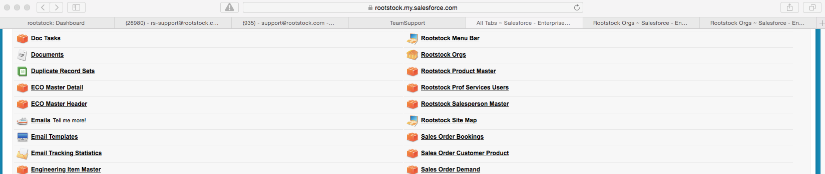

2. Navigate to ‘Rootstock Orgs’ list view & Select the org for which we want to check the expiration date.

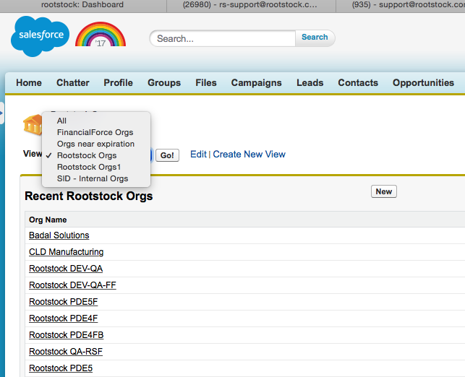

3. Navigate to the detail page of that org, as eg. we will check org expiration for ‘Badal Solutions’ org.

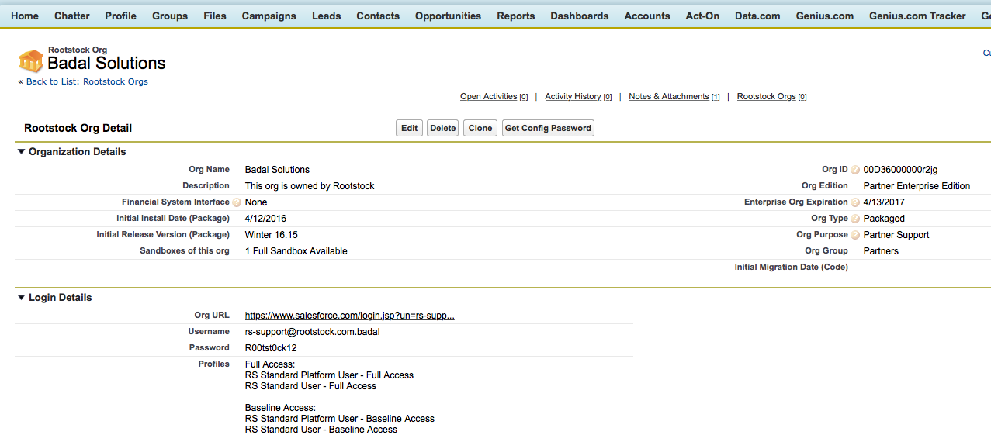

4. Copy the org URL or username password from the detail page shown above and login to the org in a new browser session.

Here on the right top corner we can see the ‘number of days’ remaining for org expiration.

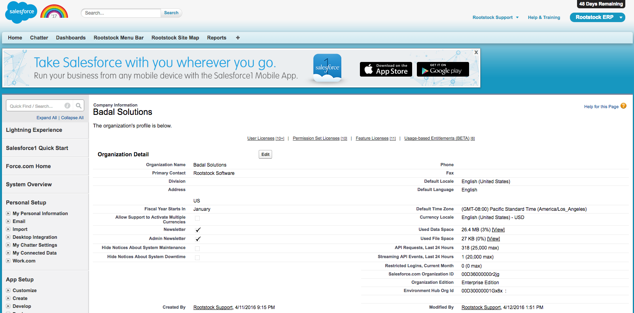

5. Go to Developer Console as shown of this org whose expiration date is to be found.

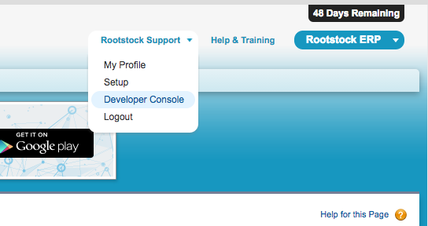

6. In the Developer Console, Debug -> Open Execute Anonymous Window

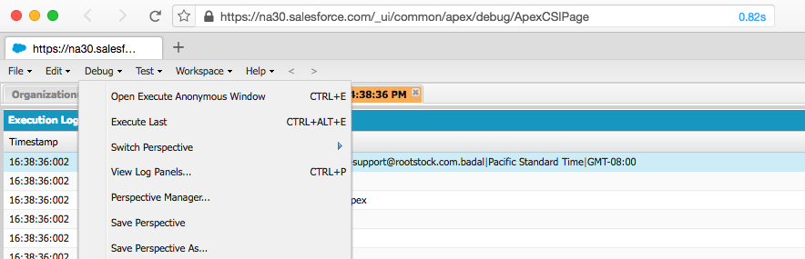

7. Execute the given query as shown in the developer console, and click on ‘Execute’ also check the ‘Open Log’ checkbox.

organization o =[select id,TrialExpirationDate from organization];

system.debug('org Expiry date is'+o.TrialExpirationDate);

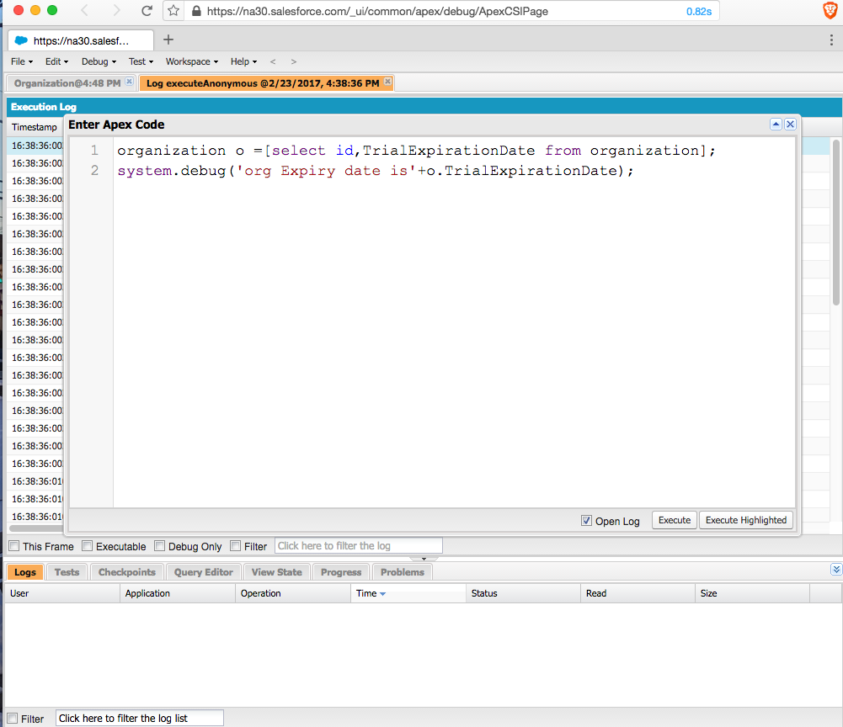

8. Note the ‘TrialExpirationDate’ in the log, this is the date when the org will be expired.

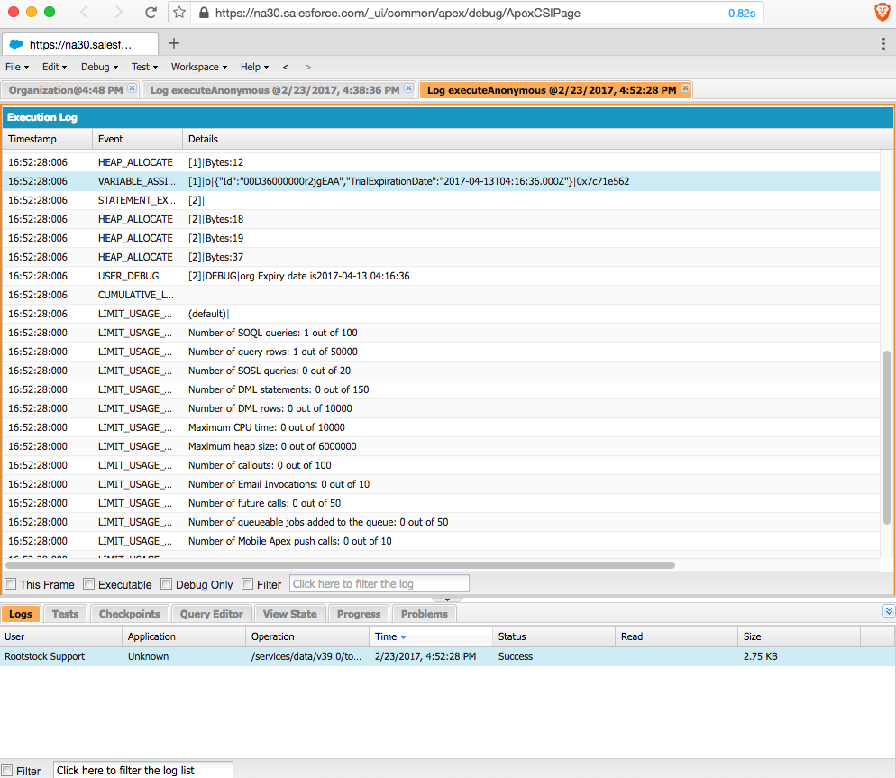

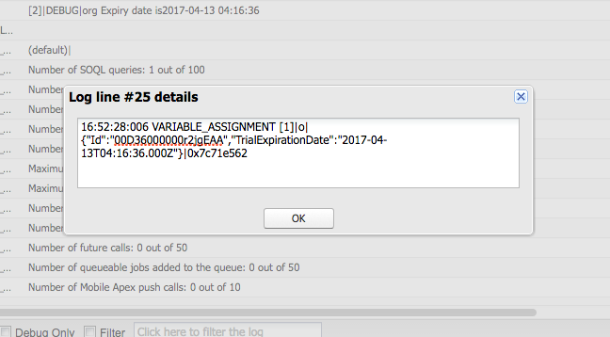

9. Raise a support ticket with Salesforce for the Trial org expiration for this you need to have the partner community login credentials. 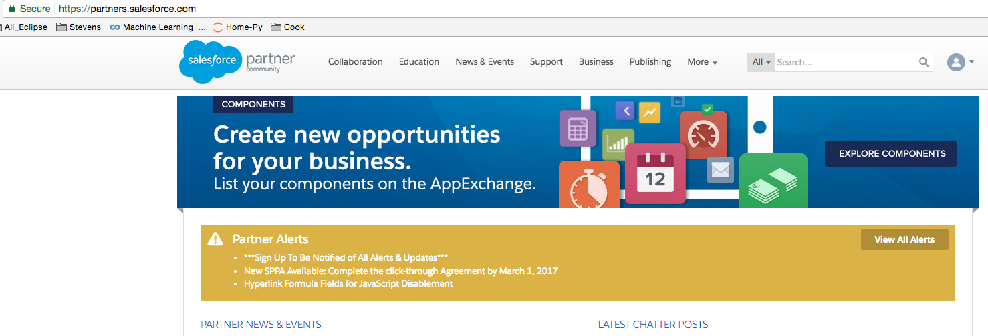

10. Once logged in to partner community, click on ‘SUPPORT’ tab and the ‘New Case’ button.

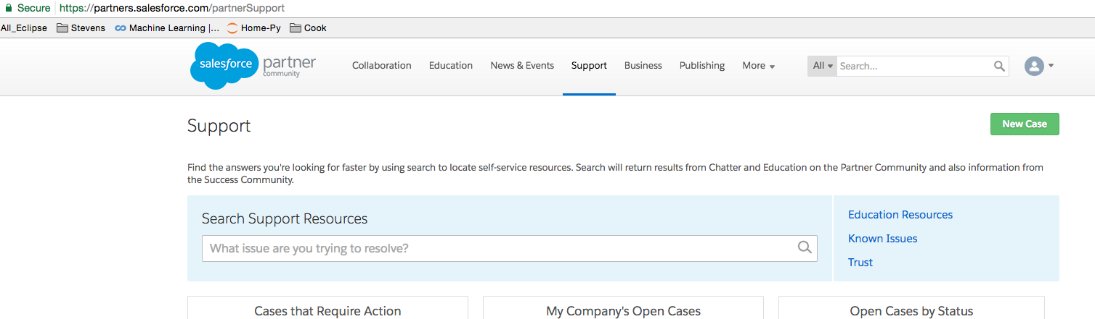

11. In the ‘General’ section, hover your mouse in the ‘Trail Org Extension’ and click ‘Create a Case’ button in the pop-up window.

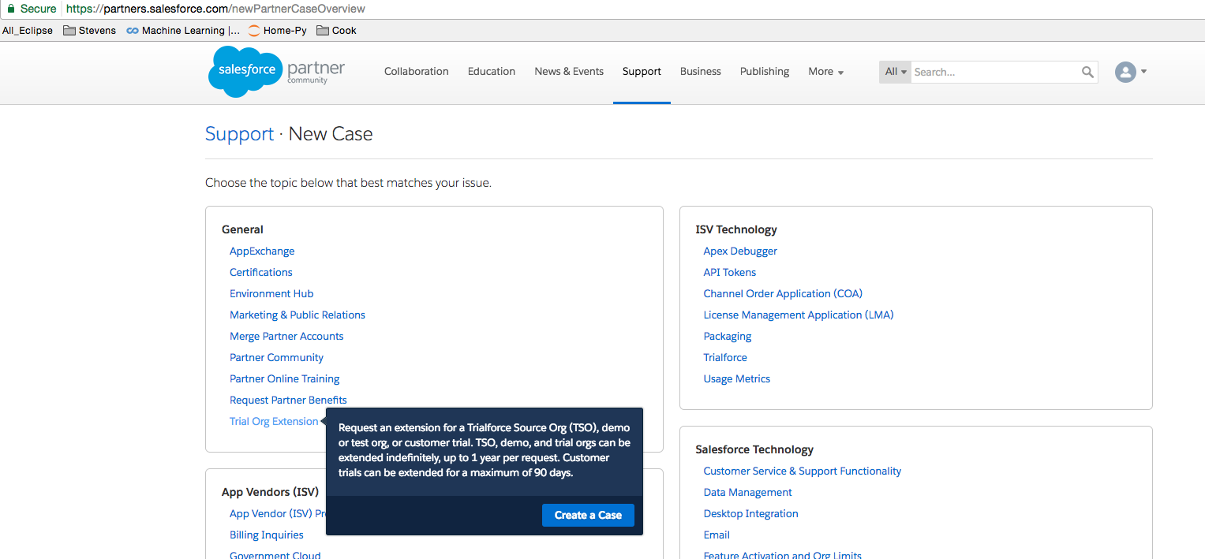

12. This is an example of details that need to be included while creating a case with salesforce. Please note mentioning the **ORG ID** of the org whose expiration date needs to extended is important to mention as shown in the below screenshot.

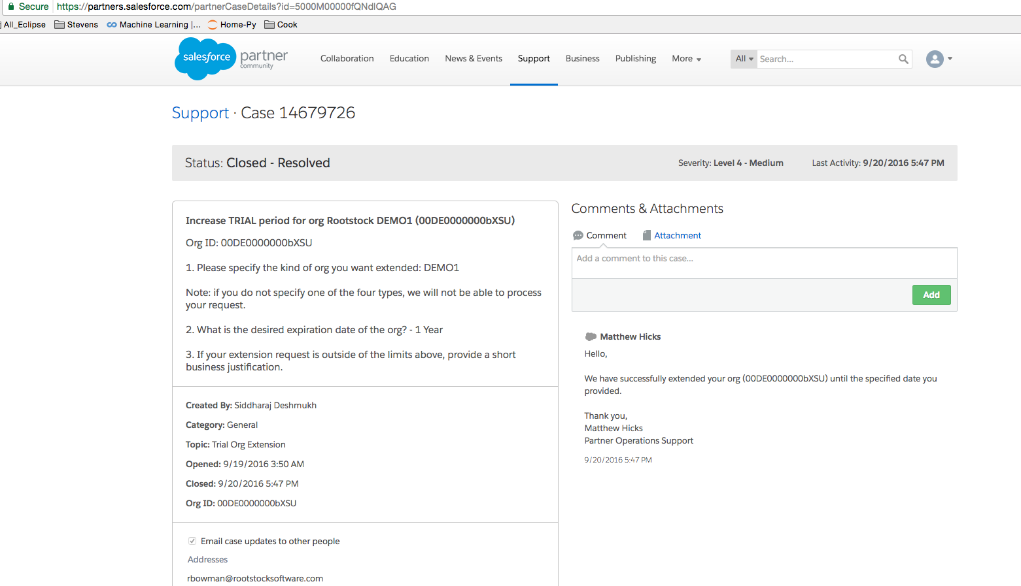

You will receive and email when the salesforce executive is working/updated and resolved the case ticket, this email is of the user whose credentials were used to login to partner portal and create the case.

13. Update the ‘Enterprise Org Expiration’ date in the detail page of Rootstock LMA org.

